User Guide Hermes - For Access Request

For Internal Users (with microsoft.com email domain):
- Navigate to the following URL to request access
- First time users should allow the pop-up redirects
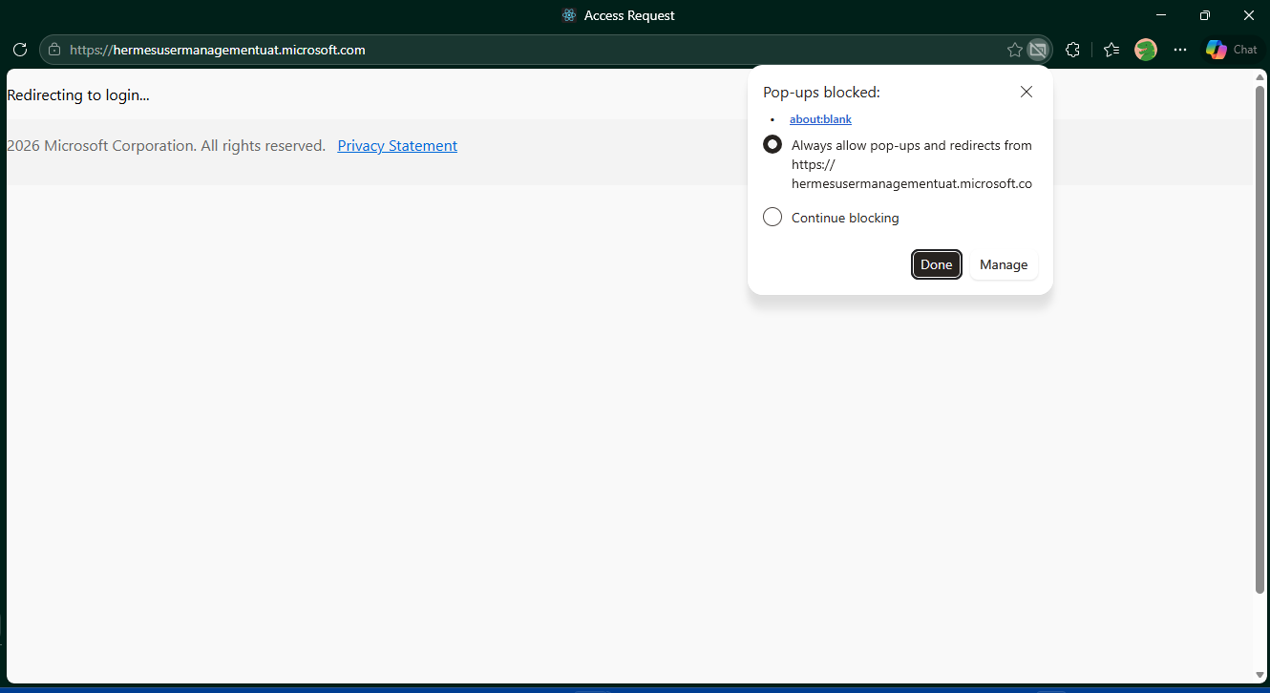
- Please enter/select all the mandatory fields as shown below and click on Submit button.
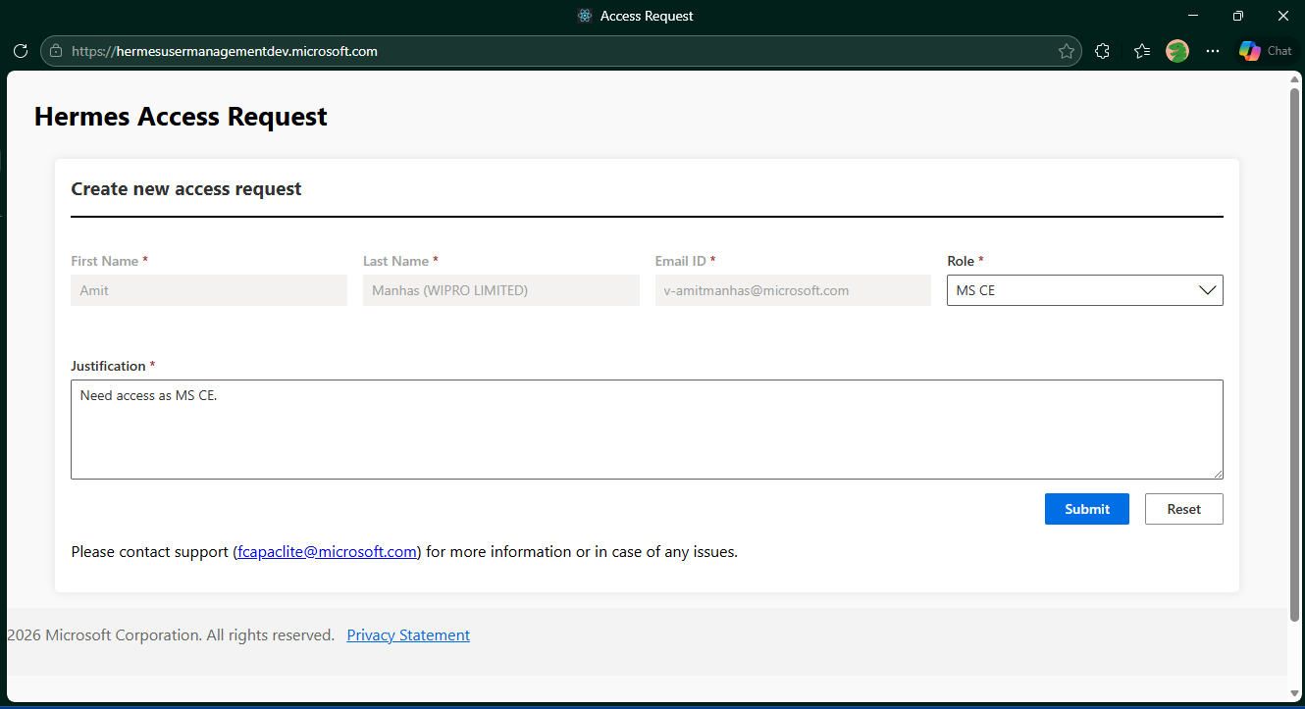

- You will see the following message after successfully submitting the request
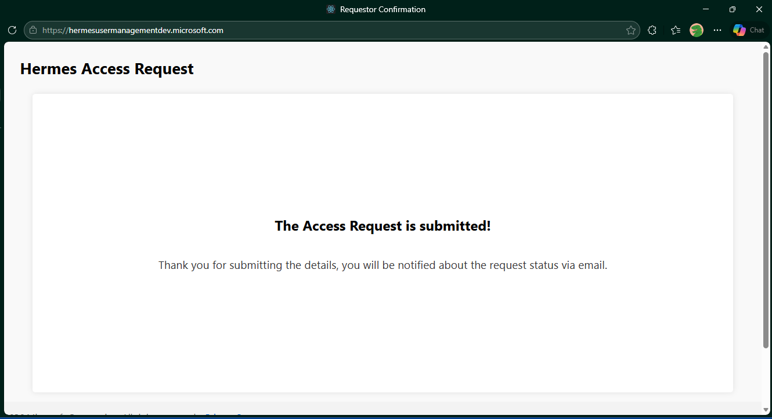

- Once your access request is approved, you will receive the invitation mail from Hermes Portal
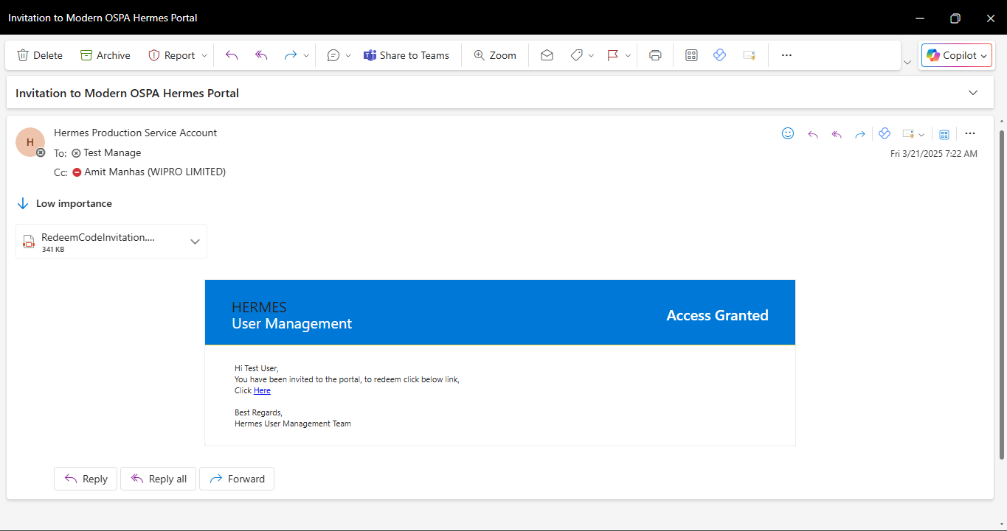

- For any queries or issues, please reach out to Field SharePoint Services Team <fcapaclite@microsoft.com>

User access review :

- Existing Hermes users will receive access review notifications from the Hermes Production Service Account .
- The email subject will be ‘Action Required: Review Your Access to Hermes Portal – Expiry by MM/DD/YYYY’.
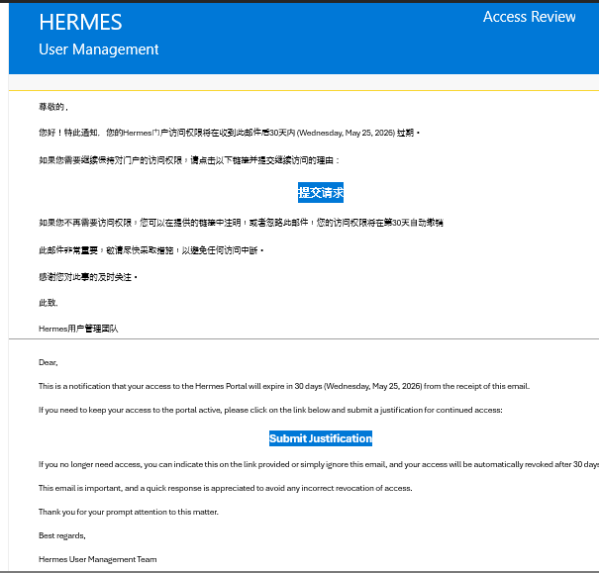
- There will be two notifications sent with the final one, sent a week before the 30-day expiry.
- Users will be required to confirm or revoke their access based on current business needs (see screenshot below):
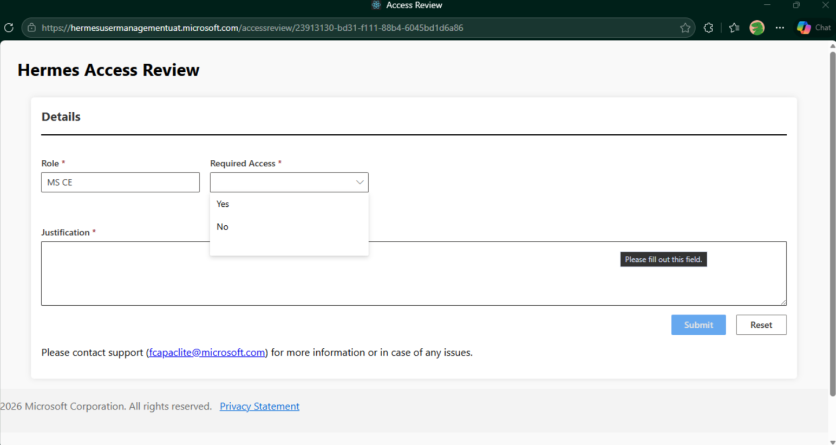

- If no action is taken either on the first notification or the second, then access will be automatically revoked on the 30th day from the date of the first email.
- Users will need to follow the ‘New Request access’ process again if access is revoked.
- Access reviews will occur every 180 days.

